Instructions: Fill up the required information: name and student ID.

For multiple choice highlight the correct option.

After completing all the questions save the file and submit.

Name: Kobilov Ilkhomjon Student ID: 201923250

**Section - 1**

Multiple choice questions: Choose the correct answer. Each correct answer is worth 1 point.

1. If there are multiple start codons, how can you identify the real start codon?
2. By observing Okazaki fragments
3. By identifying splicing site
4. Using sequence databases
5. By identifying Kozak sequence
6. Which one is not a part of the transcription unit?
7. RNA primase
8. Promoter
9. RNA coding sequence
10. Terminator
11. A mutation that does not alter the amino acid is called a ____
12. Silent mutation
13. Inversion mutation
14. Deletion mutation
15. Frameshift mutation
16. In secondary structure of protein__________
17. Only the amino acid sequence is present
18. Alpha helix is present
19. β-sheet is present
20. Both b & c
21. DNA is made of two strands that are antiparallel. If one strand runs from 3’ to 5’ direction the other one will go from 5’ to 3’ direction. **During replication or transcription, whatever the process is, it will always follow the 5’ to 3’ direction** using the 3’ to 5’ directed strand as the template strand. Therefore, if following is the DNA sequence

5’-CCG ATC GCA CAA-3’

1. Using this sequence as template after transcription no protein can be translated. Why?
2. Presence of start codon
3. Absence of start codon
4. Due to mutation
5. If you want to start the translation, what change do you need in the second codon (from 5’ to 3’ direction)?
6. Substitution of C with G
7. No change
8. Deletion of C
9. Both I & III
10. Refer to the figure and answer the following questions.

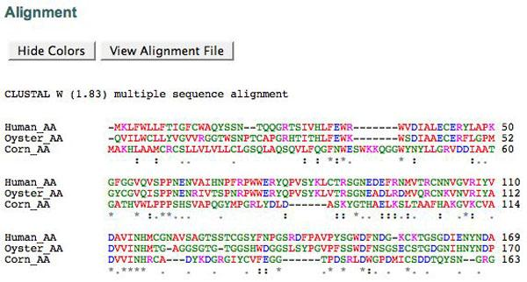

Figure: Sequence alignment

1. How many different species are used as the source of sequence in this analysis?
2. two
3. one
4. three
5. four
6. What does the (*) mark mean in this alignment result?
7. Evolutionarily conserved region in all the sample
8. Evolutionarily not conserved
9. Similar type of amino acid is present
10. A triplet of mRNA is called a?
11. anticodon
12. peptide
13. amino acid
14. codon
15. Original: ATTTGAGCC

Mutated: ATTGAGCC. This is an example of what kind of mutation?

1. Inversion
2. Insertion-Frameshift
3. Deletion-Frameshift
4. All of them

Section-2

Definitions: Write the definition (Briefly in the box) of the following terms. Each definition is worth 2 points.

1. Open Reading Frame:

An open reading platform is the component of a reading framework in molecular genetics that can be interpreted. An ORF is a continuous codon stretch that starts with a beginning codon and finishes with a stop codon. An ATG codon may mean where translation begins inside the ORF.

1. Molecular Evolution:

The molecular production of the cellular molecules such as DNA, RNA and proteins is a mechanism of improvement in sequence structure over centuries. The field of molecular evolution uses evolutionary biology theory and population genetics in order to clarify trends.

1. Bioinformatics:

Bioinformatics is a cross-disciplinary field that develops biological data interpretation methods and software tools, particularly where data sets are broad and complex.

1. Missense mutation:

Genetics is a mutation in misstate that refers to a codon that codes the codon for a particular amino acid by a single nucleotide shift. It is a kind of unnamed substitute.

1. Transcriptome:

The transcriptoma is the collection of all RNA transcripts for each individual or group of cells, including coding and non-coding. Depending on the experiment in question, the term can often be used to refer to any or just mRNA.

Section-3

Critical Thinking: Answer the following questions using proper logic. Each question is worth (2+4+4) 10 points.

1. Following is an mRNA sequence reported in the database.

5’ ACC AGA ATG ACC ATG GCA 3’

1. There are two ATG’s. From which the translation can be initiated.
2. 1st ATG
3. 2nd ATG
4. None
5. If there are multiple possible start codons, how can you identify the original start codon? Explain.

Your Answer:

The start codon is called AUG, because it is the first codon to be translated into the transcribed mRNA. AUG is the most commonly used START codon, which codes in eukaryotes for methionine acid and prokaryote formyl methionine.

1. This is an mRNA sequence, but why are there T’s instead of U’s? Explain.

Your Answer:

These are the codons that are read about the DNA strand of the sense (5' to 3'). They read the same codons as RNA, except that nuclear thymidine (T) is found in place of uridine (U). However the DNA antisense strand ( 3 to 5') as the template is currently synthesized by mRNA

Section-4

Database usage test. This task is worth 10 points.

1. Go to the website of Protein data bank (<https://www.rcsb.org/>) and search for COX-1 and COX-2 protein. Get the FASTA sequence of both. Open <https://www.ebi.ac.uk/Tools/msa/clustalo/> in another tab for sequence alignment. Use the FASTA sequences for alignment sequence. Take a screenshot of the analysis and paste here.